CDMAC AIRFIELD / SAFETY RULES

- All members must observe field discipline and comply with the Air Navigation Order, all relevant BMFA safety codes as contained within the BMFA Members’ Handbook and Civil Aviation publication (CAP) 658.
- Members must carry their airfield permit and BMFA proof of insurance at all times when flying. The airfield permit must be shown to SLA representatives on request in a courteous manner.

- On matters of field safety needing an immediate decision, the responsibility lies with examiners, instructors or a member of the committee in that order. Any instructions must be accepted without dissent. However, should a member believe the instructions to be wrong, then he should bring this to the attention of the Committee through Article 14 of the Constitution.

- Any pilot not holding their solo qualification for the type of aircraft they are flying must not fly without the supervision of an instructor or their specially appointed deputy if the instructors are absent from the field. If no instructors are present at the site, any member holding the BMFA ‘A’ Certificate in that specific discipline may act as an appointed deputy until an instructor arrives.

- Due consideration must be given at all times to trainee or novice pilots in the circuit. In the event that the pleasure or concentration of a pilot is affected by the flying style of another, precedence will be given to the pilot who was airborne first. Intimidating flying of any sort is not permitted.

- No more than 4 aircraft shall be airborne at any one time.

- The flying of multicoptors (drones) is not permitted at Kirkbride

- First Person View flying is not permitted due to the proximity of full size aircraft flying.

- All flying is to be done in the designated areas only. The Appendix defines the detail for normal flying and for winter flying in low sun conditions. The winter flying arrangements will apply between 31st October and 28th February. There are to be no exceptions to these rules unless authorised by a committee member, and members may expect to be disciplined if they ignore them.

- Runway 28 is the main airfield runway for piloted aircraft, and is not to be used by CDMAC members flying (other than CDMAC jet aircraft, see additional rules). Runway 23 is the CDMAC runway.

- No models to be flown at a height greater than 400ft above ground level.

- Overflying any of the areas below, other than under emergency flying circumstances or landing finals (above 50 feet), is forbidden:

  - Runway 28
  - Either of the two roads to the north and east that border runway 23
  - Any of the residential houses or commercial premises.
  - The pilots’ area, pits or car parking areas.

- All pilots must observe the established flight line and stand in the designated area (marked by a yellow line on the runway) whilst flying. Pilots must take off and land upwind of the pilots’ area. Cars are to be parked downwind of the designated pilots’ area so that there is no parking directly behind the pilots.
Yellow lines at right angles to the runway indicate the extent of the pilots’ area at the edge of the runway. New arrivals should park downwind of the last car in the line. Any variation to suit daily conditions may be made by the Club’s committee. Any spectators must remain within the car park area whilst flying is in progress.

- Any person wishing to enter or cross the runway area must seek clearance from any pilots flying at the time before doing so. All vehicles must be parked in the designated area only.

- Where there are very limited numbers of members flying with 35mhz radios, the minimum requirement will be to announce each frequency to all users, and ensure that no conflict occurs. When there is a substantial number of members operating on 35mhz at one time, it will be necessary to operate a pegboard system.

- Before switching on 35Mhz radio, the pilot must ensure that he is operating on the frequency he believes he is on and must display the appropriate frequency pennant on his transmitter. All 35MHz transmitter aerials must remain retracted unless the model is being flown. The flight is defined from the point of release to when the engine is stopped or the model is restrained. All radios and modules must conform to UK and BMFA legal standards.

- Transmitters should not be taken away from the flight line when retrieving an aircraft, unless to do so would aid retrieval of the model. In this instance the matter should be brought to the attention of other pilots so that this may be carried out without the risk of over-flying the transmitter.

- Should an aircraft go out of control, the first priority must be the safety of persons with the second being avoidance of damage to property. A warning is to be shouted by the pilot which is to be taken up by other members. Where an aircraft is seen to lose equipment during a flight, it must be landed immediately as an emergency situation. All landing manoeuvres are to be declared loudly by the
pilot – all low flying other than landings are to be on the opposite side of the runway to the car parking.

- Before starting an engine the model must be suitably restrained either by a tether or by an assistant. In the interest of safety, assistance should be sought when running up engines and taking models to the runway for take-off. All helpers must have BMFA membership.

- Appropriate use should be made of all available pit area, and under no circumstances should engines be set up in the immediate vicinity of the pilots who are flying at that time. Where practical, models should face outward from the pit area.

- Under no circumstances must an engine be run unless all persons are behind the line of the propeller with the exception of the person starting the engine. When carrying out power checks all persons including the pilot are to be behind the line of the propeller.

- Engines being run in on the ground must not be left unattended whilst the engine is running.

- All new or repaired models should be checked out by an experienced member before being allowed to fly. All models are subject to random safety spot checks which will be carried out by a committee member. If in his opinion a model is unsafe to fly or does not conform to Club rules, it will be grounded until rectified.

- Members must ensure that they comply with the D of E Noise Code for the Minimisation of Noise from Model Aircraft. “Add on” silencers and “quiet” propellers should be fitted unless the model emits below 82 decibels at 7 metres without them. Notwithstanding if in the opinion of the Committee a model is excessively noisy in the air, then it is to be grounded until rectified.

- All operational failsafes in use on powered models operated from our Club site must set the throttle to tick-over, not hold, (and stopped in the case of electric power) regardless of the other control operations governed by the failsafe. Failsafes are to be checked prior to flight by switching the transmitter off whilst the model is restrained.

- No person shall attempt to retrieve a model from any land adjacent to the flying site without prior consultation with the appointed safety officer for the day, to ensure that the situation is properly assessed and minimal disruption caused. If it is considered by the safety officer that the landowner’s permission should be sought before retrieving the model, it will be the owner of the model and one of the safety officer who must approach them for permission.

- Mixed site operation – the BMFA rules for mixed site operation must be observed. Full-size piloted aircraft (FSPA) have priority on all runways at all times. FSPA may need to use runway 23 occasionally. All CDMAC fliers will land their aircraft as soon as possible in a safe manner and clear the runway. Microlites and autogyros may require the use of the grass strip adjacent to runway 23 at times – members are to ensure that these landings are not obstructed. If members cars are parked on the required landing side of the runway, they are to move them to the opposite side of the runway as soon as possible. There will be no CDMAC flying in close proximity to FSPA. See also additional procedure relating to helicopter pleasure flights.

- Mobile telephones must not be taken onto the flight line.

- 2.4 ghz camera systems are strictly prohibited on the airfield.

- Children must be closely supervised at all times and must not be allowed to run around the pit area or runways.

- No dogs are permitted at the flying field unless kept on a lead or tethered.

- Any incident involving a third party or another member must be reported to the Committee as soon as possible.

Apppendix

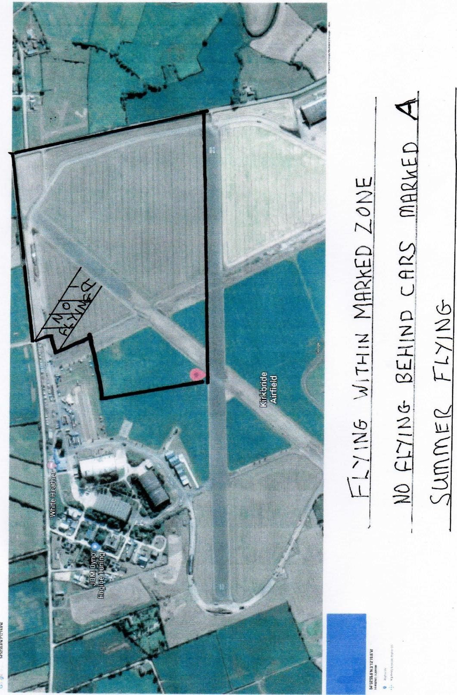
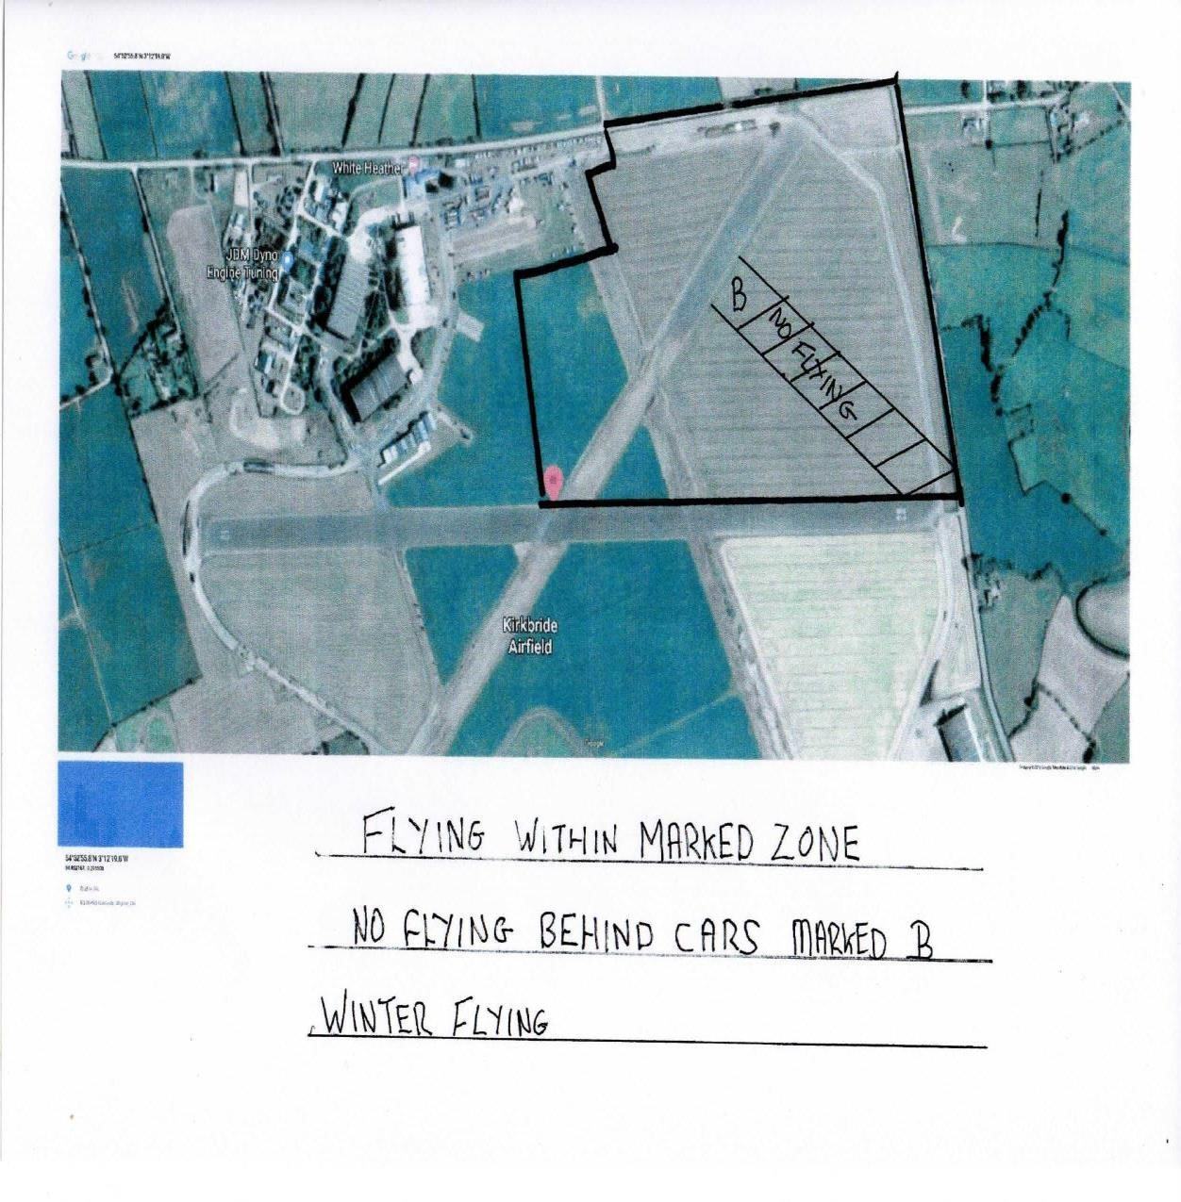

-

HELICOPTER PLEASURE FLIGHTS: KIRKBRIDE SAFETY PROCEDURE
When you arrive on the airfield look over to the heli pad. This is beside the hangers to the right of the tower. If you see a helicopter on the pad and/or a red and yellow striped vehicle which is the safety vehicle that accompanies the helicopter then this indicates that pleasure flights are being operated and the following procedure must be carried out.

- The first member on the airfield must go over and advise the crew where we are and that we are flying model aircraft. No model flying shall take place until this has been done

- Members will only fly if they feel it is safe to do so. It is not safe if the helicopter is on approach to land over our site.

- All model aircraft are to be landed before the helicopter overflies our site.

- As the pilot you will be held responsible should you put any fullsize aircraft in danger. Article 240 of the ANO applies.

- Fullsize aircraft take priority even if they do overfly our zone.

- You must be extra observant if you are flying on your own and listen as well as look. if there are 2 or more use an observer.

- There is much more fullsize activity on Kirkbride now especially at weekends so be observant do not ruin your site by being irresponsible

- The above procedure forms part of the club safety rules and failure to comply with it will be considered a serious breach of rules and subject to disciplinary action in accordance with the procedures set out in the club constitution and disciplinary procedure.

